The Ideal Way to Organize AK! WHAT TO DO FIRST, NEXT & LAST!

QUINTESSENTIAL APPLICATIONS
8 ATLANTA WORKSHOPS

“Finally, someonehasdonethenear impossible! Imaginethe40+yearsofAKorganizedintoaworkable… hierarchy of what needs to be done first, second and next. Follow the QA protocol and know what to do for any patient on any visit!” - Scott Walker, DC, Encinitas, CA…N.E.T. Founder

These QA Workshops Are Designed to Complement the QA Home Study Comprehensive Online Course

Doctors: https://qahomestudy.com/amodio Students: https://qahomestudy.com/amodio/student

SESSION & DATES:

Workshop 1: Oct 9, 2021

Workshop 1: Nov 20, 2021

Workshop 2: Jan 29, 2022
TOPICS:

Hands-On Pain Relief / Hip and Low Back (QA Sessions 1 & 2)

Hands-On Pain Relief / Hip and Low Back (QA Sessions 1 & 2)

Shoulder/ Fatigue & Inflammation (QA Sessions 2 & 3)

Workshop 3: Mar 5, 2022 Spinal Adjusting/ Fatigue & Inflammation (QA Sessions 4 & 5)

Workshop 4: Apr 23, 2022

Workshop 5: Jun 4, 2022

Workshop 6: Jul 16, 2022

Workshop 7: Sep 10, 2022

Workshop 8: TBD
Head & Neck / Immune System (QA Sessions 6 & 7)

Digestive System/ Lower limb/ Low Endocrine Function (QA Sessions 8 & 9)

Adrenal Stress/ Emotional Techniques/ Chemical Hypersensitivities / Liver Detox (QA Sessions 10 & 11)

Upper Limb / Liver detox / Hyperinsulinism / Stopping Joint Degeneration (QA Sessions 12 & 13)

Common Glandular Dysfunctions / Common Metabolic Dysfunctions / Immune System (QA Sessions 14 & 15)

In order to achieve a complete educational experience, it is highly recommended that the participant study the respective QA Sessions online prior to attending the QA Workshops.
Doctors: https://qahomestudy.com/amodio Students: https://qahomestudy.com/amodio/student
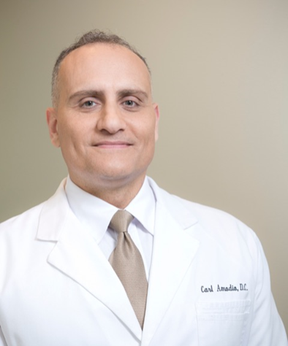
Carl Amodio, DC, DIBAK has been in practice since 2001 and received his Diplomate from the International Board of Applied Kinesiology in 2011. He began incorporating the QA Clinical Protocol into his practice in 2005 while attending the inaugural QA Course. He is a graduate of Life University (Life) and is the owner of Optimal Health in Roswell, GA. He is on faculty at Life teaching the elective course: Introduction to Applied Kinesiology, which he designed and introduced in 2006 at the request of his friend and colleague Dr. William Harris.

Dr. Amodio helped start the first ever AK club on Life campus in 2006. He is currently the faculty advisor for the club which, with much excitement and interest, is still going strong today. Dr. Amodio has been a QA co-lecturer and workshop leader and is now excited to be conducting the first QA Workshop series ever to be held in Atlanta!

LOCATION & TIMES: (Workshops 1-8)

LOCATION & TIMES:
Life University, CCE 117, Marietta, GA SATURDAYS: 9:30 to 5:30 PM

SEMINAR FEES (per session):

Doctors: $250 Students: $150
$25 discount for payments received 30 days prior to the seminar date

CANCELLATION (Transfer) POLICY:

A $25 cancellation fee will be charged for cancellation within 10 days prior to any session. However, the seminar fee may be transferred to another session at no charge.

WHO IS ELIGIBLE TO ATTEND: THIS COURSE IS OPEN TO DOCTORS LICENSED TO DIAGNOSE AND STUDENTS IN A DEGREE PROGRAM LEADING TO A LICENSE TO DIAGNOSE. THIS IS IN KEEPING WITH THE GUIDELINES OF THE INTERNATIONAL COLLEGE OF APPLIED KINESIOLOGY.

Treatment Tables Will Be Provided – But Feel Free To Bring Your Own
REGISTER:

PLEASE PRINT LEGIBLY:

First Name ______________________ Last Name ________________________________ Degree _____

Address _________________________________ City ___________________ State _____ Zip ________

Tel __________________________________ Email __________________________________________

VISA/MC/AMEX # ______ - _______ - _______ - _______ EXP ___ / ___ CVV ____ Zip ________

Make Checks Payable & Mail to: Optimal Health
555 Sun Valley Dr. NW, Suite A1 Roswell, GA 30076
(770) 993-4633

PayPal email: drcarl3@pm.me

In Order to Ensure Optimal Learning, Participation will be Limited REGISTER NOW!

Go to the links below and purchase the QA Online Course Begin Studying for the Next QA Workshop

Doctors: https://qahomestudy.com/amodio Students: https://qahomestudy.com/amodio/student

